More Than > Sunday. Us. Now.

#6: Commitment Sunday

Luke 12:1-4

Dr. Matt Cassidy ---- September 27, 2026

Today is going to be a wonderful, wonder-filled day. Grace, we make history today. We make history as a church, and we’re going to make history as individuals. If you’re visiting today, this is not like any other Sunday. Just enjoy. Watch and drink it in. You can be a spectator if you want or you can jump in and hear what we have to say and participate with almost no context.
The bigger context of what we’re experiencing today is this: we’ve been working six weeks on a journey (more like an adventure) where God is always out to cause us to do scary things together. And this adventure is focusing on how to become like Christ--in particular, with generosity. How do we become like Christ in generosity?
And we are out to be set free from the anxiety that comes, or the pride that is sometimes related to our resources that God has lent us. And it causes us to live a life, in many ways, independent of Him and not trusting in Him.
So, we’ve been working on having a transfer of trust from our hard work and whatever to trusting in God and realizing that He’s been doing the hard work in our lives. What are the odds that we would be here and now? And the odds are one hundred percent that God is doing those things.
So, we’ve been learning one thing for sure together. And if you grasp this one thing, it will change your life. You can change the way you see all of reality if you get this one thing. I won’t even tell you what the one thing is. I’ll tell you a story instead.
I read a great little testimony from a woman who was a business traveler, and she was writing that in her last business trip she got to the airport early. And so, she went and got a little bag of cookies and went to the lounge and sat by the bar and got out her Southern Living magazines and started to read. And then she suddenly heard beneath her magazine the rustling of that bag of cookies. And she looked over and there’s a well-dressed man next to her, and he ate one of her cookies. And so, she was stunned that it was even happening. But whatever … she went on ate some cookies, and then back to her magazine, and ate some cookies. And then she heard the rustling again. And he’d gone and eaten another cookie. And so, now she’s more than stunned. She’s angry, but not enough to say anything about it. But finally, it got down to the last cookie. And she puts her magazine down, and he has the last cookie. And so, he looks at her and smiles. And then … the nerve … he breaks it in half, winks at her, and gives her half. And then he eats the other half.
It’s time for her to go. She’s had enough of this stranger anyway. So, she’s in line to board her plane, and she reaches in her purse to get her ticket out and then pulls out a bag of cookies, and it’s unopened. He wasn’t eating her cookies; she was eating his cookies. They were his cookies!
Psalm 24:1, 8, 10

The earth is the Lord’s, and everything in it, every nation, every throne, every ruler bows beneath His reign. ⁸ He is the Lord, strong and mighty. ¹⁰ He is the King of glory.

That’s what we learned over our time together—who owns the cookies. This is the lesson that you can build your life on. It’s summarized in Psalm 24: “The earth is the Lord’s, and everything in it, every nation, every throne, every ruler bows beneath His reign. He is the Lord, strong and mighty. He is the King of glory.”
“The earth is the Lord’s”—and what else? “Everything.” Everything belongs to the Lord. All the cookies belong to the Lord. Your house? That’s His house. Our savings, our clothes, every breath we take, is all the Lord’s. And it’s just on loan to us so that we can make the very most of it. When we think that what we earned is ours and our possessions, we find ourselves taking ourselves too seriously or becoming too anxious, because we put hope in something that can be lost or stolen.
While the first truth that we learned is the foundation—all belongs to the Lord—the application for that is that we are just stewards. We’re just the managers of someone else’s resources, of God’s assets. And our job is to use what God has given us for His glory. I mean, boom! That’s the meaning and purpose of life, literally, to understand that God owns everything and we manage what He’s lent us to make heaven crowded and make Yahweh famous—make God famous.
And if that’s the meaning and purpose of life (and it is), then no wonder that our primary goal for our whole time together, our campaign, our project—whatever you want to call our weeks together—our primary goal is one hundred percent participation. We want every single person involved to search the Scriptures and find out for himself or herself that that, in fact, is true: that all things belong to God. And then if you come to the obvious conclusion that it all belongs to God and we’re just lent that for His glory, to show Him what we can do with it, then we can pray this prayer. This is what we wanted everyone to pray, one hundred percent participation. Find out what the Bible says about all things belonging to God. And then one hundred percent participation in praying, “Dear God Almighty, ruler of the universe, rule me. Rule my soul. And with all that I have been given in this very short life, I want to go anywhere at any time to do anything with anyone. I want to use my literal resources to make heaven crowded and to make You proud. I want to glorify God.”
So, one hundred percent participation is like no man left behind. That’s our desire--that we want every person to say, Christ is my King. We want no one to be left behind in on this peace train.
What a great way to live—trusting in God for resources and our future and our security. Why wouldn’t we want everyone to do that?
So, that’s what we’ve been up to. Now I think I mentioned that we had an advance commitment night. That was two Sunday nights ago. It was a beautiful night, and I want to give you an update on what happened. We had pastoral staff and other staff members and some of our elders and some ministry leaders and some people who are just committed to Grace Covenant Church. We gave them a heads up on a lot of the things that we’ve been doing, and we wanted to have an advance commitment night. It was a beautiful night. It was wonderful. It was a mosaic service like we do here, with stations to go to and experience communion (the Lord’s table) together, and places to pray. We had a praise wall set out on the stage. Those are out in the lobby now. You can see where people were praising and thanking God.
But the climax of the night (it crescendoed with each of those early givers coming and presenting their offerings to God) was when they put their cards in this baptismal here. They turned their cards in and we just celebrated. It was a hoot. We had seventy-nine families turn in cards that night and lead the way for the rest of us.
And here are three little points of contact that I want to thank God for. Let’s loosen up our hands and clap. Nine families out of the seventy-nine had never given before to Grace Covenant Church. They are first-time givers—they have jumped in the pool. That’s impressive. So, why don’t you give those guys a hand. [Applause from the congregation.]
Another fun little thing that we know at this point because of some data mining done by our accounting people: a significant number of families that were already regular givers made a radical increase in their giving. I mean, they radically changed, some to 600% more. Because, as you’ve seen over these weeks together, one of our values is to make Grace Covenant Church your favorite child in giving, your favorite place to give your resources. And some people have made that a real thing. So, give those guys a great praise. [Applause from congregation.]
And then, not only do we have nine first-timers and radical regular givers increasing their giving, but the last thing they were able to determine by looking at the data is that people are going into significant giving, maybe even sacrificing to give out of stored resources. So, all I can say is that I think there’s going to be a lot of boats for sale over the next month or so.
Overall, the person who’s been advising us for well over a year and working us through this process (because we needed so much help with it) said these words: “These are phenomenal results in setting a pace. Your pacesetters set a great pace.” So, let’s thank the pacesetters for what they’ve done. [Applause from the congregation.]
Here’s a short, maybe two -minute video … a clip of some of the people who were there and their response after they gave those gifts. So, roll tape:

+++++++++++++++++++++++++++++++++++++++++++++++++++++++++++++++++++++
Video Link from Advance Commitment Service

https://www.dropbox.com/scl/fi/wbo3i863hnc9a7s2t4iik/More-Than-Advance-Commitment-Night-v3.mp4?rlkey=0jodqccm0lffddzdhzgcqr9md&e=2&dl=0

Person #1 (Jamie Tucker): Money has always been an idol of mine, and I grew up with not a lot of money. So, Grace doing this is giving me the opportunity to surrender an idol and a fear and really trust in God and let go of the control.

Person #2 (Bill Tucker): More Than has taught me that it all belongs to God in the first place. It’s like when a kid buys a Christmas gift for their parents using their bank account. It’s all his anyway. And it’s been extremely freeing for me personally to understand that it all belongs to Him.

Person #3 (Cheryl Carrell): I’m just praising the Lord that every aspect of my life has been shaped by this church and the people here. It’s easy to step forward and know that God is going to use it. And I don’t know how it’s going to look, but I’m excited to be a part of whatever that next journey is here at our church.

Person #4 (Morgan Vyssotski): I’m really hopeful for knowing what’s going to be built across the highway and just how many people God might bring here, that there will be many who don’t know Him yet, who are far from Him, that might come to church for the first time and encounter relationships with believers for the first time and be invited.

Person #5 (Carl Hannusch): I got to look around the room tonight and just feel that I’m a part of what God is doing here. There are so many people that I look up to and so many people who are role models for us. It’s a blessing to be in this room and, as Matt says, leave fingerprints on what God is doing next at Grace.

Person #6 (David Crowley): I’m honored to be a part of this, because we were sitting in the midst of the body of Christ here at Grace and realizing that a lot of these people we were sitting around have gone before us. And they have sacrificed in a way where we ourselves have benefitted, and our kids and this community that we’ve grown in. And now we are in a position where God has given us the ability to bless those who come behind us.
+++++++++++++++++++++++++++++++++++++++++++++++++++++++++++++++++++++
Isn’t that fun?
A famous author, Robert Fulghum--you might have read one of his books, All I Ever Needed to Know I Learned in Kindergarten. Anyway, he’s written a lot of books, and he’s got this one beautiful story that I feel like helps us grasp our place in God’s creation.
He talks about when his youngest daughter was in preschool, and he was going off to work, and she had prepared him a special something. She had these two paper bags, and she ran out to him as he was getting in the car. One was his lunch, and one was special things for him to bring to work. He’ll see.
So, he goes to work, and it’s lunchtime, so he empties the bag. Here’s the inventory of the things his daughter gave him: two ribbons, three stones, a plastic dinosaur, a pencil stub, seashells, a used lipstick, two Hershey’s Kisses, and three pennies. Anyway, he saw that, and when lunch was over, he put everything back in the bag and then threw it away … yeah. Some of the moms are moaning and the dads are saying, What?
Let me read this to you. Later when he got home, his daughter said, “Daddy, where’s my bag?”
“What bag?”
“The one I gave you this morning.”
“Oh, I left it at the office.”
“Well, those are my things in that sack, Daddy—the things I really like. And I thought you might like to use them and play with them while you were at work. And now I want them back. You didn’t lose my bag, did you, Daddy?’
She’s starting to cry.
He said, “No.” And he’s lying. “I just forgot to bring them home.”
“Well, you’re going to bring them back tomorrow, right?”
“Don’t worry. I’ll bring them back.”
She hugs him around the neck.
He goes to work that next morning very early. And he digs through the trash to get her treasures back. He writes, “Molly had given me her treasures, all that a preschool heart could ever hold dear. Love in a paper sack. And I missed it. Not only did I just miss it, I threw it away. So, I went back to the office, and I turned the trash can over on my desk and searched through and found the bag and the things in it. And I brought it back and gave it to Molly. We sat down and played with those things.”
And then he writes, “To my surprise, Molly gave me the bag once again several days later. It was the same ratty old bag. It was the same stuff inside. I felt forgiven. And for the next several months the bag went with me to work from time to time.
“Eventually in time, Molly turned her attention to other things and lost interest in the game. Me? I was left holding the bag.
“She gave it to me one morning and never asked for it again. And now it sits in my office still till this day, left over from when a child said, ‘Here. This is the best I’ve got. Please take it. It’s yours. Such as I have, I give to thee.’ I missed it the first time, but that bag is still in my office now.”
When you’re born on this planet, you’re issued a little bag, and you put the things that you think are treasures into it. So, Jesus says that it matters a whole lot what you put in that bag. And it matters a whole lot to whom you give it. That’s our lives. Some of the things that we consider precious in heaven are just a couple of ribbons, a rock, and a small seashell. But when we give that back to God, then it matters. That’s when it counts.
When I read that story a number of weeks ago, it made me think of another story, a true story that you might remember. In the last week of Jesus’ life, right around Passover, He’s in Jerusalem. And so, the population has at least tripled in size. And so, He’s doing a lot of teaching and is wanting to be there for all these people who are coming to Jerusalem to celebrate what God has done and to give offerings.
Luke 21:1-4

As Jesus looked up, He saw the rich putting their gifts into the temple treasury. ² He also saw a poor widow put in two very small copper coins. ³ “Truly I tell you,” He said, “this poor widow has put in more than all the others. ⁴ All these people gave their gifts out of their wealth; but she out of her poverty put in all she had to live on.”

And He takes a break from His teaching. And He starts people watching. And while that is happening, everyone is busy and there’s a commotion taking place. In Luke 21 it says, “As Jesus looked up, He saw the rich putting their gifts into the temple treasury. He also saw a poor widow put in two very small copper coins. ‘Truly I tell you,’ He said, ‘this poor widow has put in more than all the others. All these people gave their gifts out of their wealth; but she out of her poverty put in all she had to live on.’”
Widows were called “silent one” in those days because there was no one to speak for them. They were forgotten. They were walked by. And in this woman’s case, she’s an especially poor widow. She has two coins that may be the equivalent of pennies—the smallest denomination of that currency at the time. Her total resources are what you and I would leave on the counter at the grocery store when we’re paying for cash. Oh, I have two pennies left. I’ll just leave these for the next guy. And the next guy doesn’t get them. He doesn’t want them either.
That’s all she has. You know, when I give here, I don’t think much about it, honestly. I think because of the automatic payments we have it’s like autopilot. We make a decision, and then we forget about it, for the most part.
The point of that is, while I have the luxury of forgetting about giving, that’s not her circumstance. That’s not what happens to her here. This moment in time is a lifetime for her. If we could project into her decision tree and her thoughts and emotions, can you just imagine her prayers and her agonizing, her sleepless nights? What is she going to come to the temple to give when all she has to give is two pennies? Do you think she pondered this: Does God Almighty really need my two pennies? After all, there will be plenty of wealthy people coming from all over. I mean, the bank will be filled. And if I have two cents and I give them, I have no cents left. Now I’m dead broke, absolutely destitute.
But still, she chooses. And so, she walks up, and you can hear it: Clink … clink. What do you suppose she was thinking? I would think she’s saying, I did it. I’ve done this. All that I have belongs to God. I love Him so much. He has done so much for me. And now I am finished.
What she didn’t know was that at that moment, all of eternity shook. Heaven had an earthquake. Because in that moment Jesus is watching. And the angels were watching Jesus. And what would cause Him, the Messiah, to suddenly have a lump in His throat? What’s making Him stop and stare? He calls His disciples over and says, This is a spiritual fact. And He says, “I tell you the truth, this poor widow has put in more than all the others.” And He didn’t say that symbolically or metaphorically. He said that authoritatively. Jesus said that that particular gift is going to have unimaginable returns in the next life. And He said that because He is the judge of all people. He is the Creator of all things visible and invisible. He knows how it works in eternity. And He says that truth.
And when you think about how centuries have passed and empires have been raised and have fallen, and huge companies have been started and been forgotten … think about that. Over these years, with all that happening, the sound … clink…clink…is still echoing two thousand years later. That widow has had such a great impact.
Again, think of the context of Jesus seeing this happen when it happened. It’s going to be a matter of hours before Jesus is tried and stripped naked and crucified. And He yells out, “I’m finished! It is finished!”
And the Savior looks at her and says, Look what love can do. Look at her. Look at what faith is. Look at that woman’s courage. That must have meant a tremendous amount to Jesus to see that so close to His own demise and resurrection.
And now it’s our turn. That’s why this is such a great day to be at Grace Covenant Church. Now it’s our turn. We’re looking for our opportunity to stop and pray and ask for a miracle to take place in our lives. We’re going to ask God, What do You want? How do You want me to manage Your resources? That’s part one.
And then part two is the will and the courage to act on it. Lord, I want to use the gifts You’ve given me in this very short life to have consequences for eternity. I don’t want to live for just this little dot anymore. I want to live for forever. I want to use the temporal to get as many people as possible into heaven for the eternal. I want to make You famous. I want the angels to laugh and the demons to weep in the way I choose to work with my resources. That’s what we’re doing today.
Let me show you how it’s going to happen. In about seven minutes I want to go through the details. Every family, maybe multiple people in a family, everyone, one hundred percent, we’re asking you to fill out this card. We’re going to want you to put your name on it. On this card is “Matt and Melinda Cassidy.” We want you to put your name on it because it’s important for us to know so we can log it and keep track and make sure some fourth-grade person didn’t just dedicate a million dollars to this event.
We’ll use these cards to actually go to the bank to make decisions. They’ll make decisions. So, your name is important on this for a lot of reasons.
If you’ve already given, if you came to the event and were early givers, we just want you to write “DONE” on this. We just want you to write “DONE.” And the reason we want you to do that is because we want to come and bring a card up here with the rest of us. We don’t want you to miss today’s moment. We don’t want you to do it twice though—we don’t want to count your gift twice.
Here’s what we’re going to do. After we have this prayer time, after you fill out this card, we’re going to come up here and throw them into this baptismal because we’re kind of making fun of that old, maybe-true story of the Crusaders. They would say or sing, “I surrender most” in their allegiance to the Lord. And when they said, “I surrender most,” they meant “Not my sword hand. I’m going to do whatever I want with this, whatever takes.” And we kind of made fun (this is from weeks ago) that the modern version of saying “I surrender most” is not holding out their sword; it’s their wallet. “I’m going to do whatever I want with my money.”

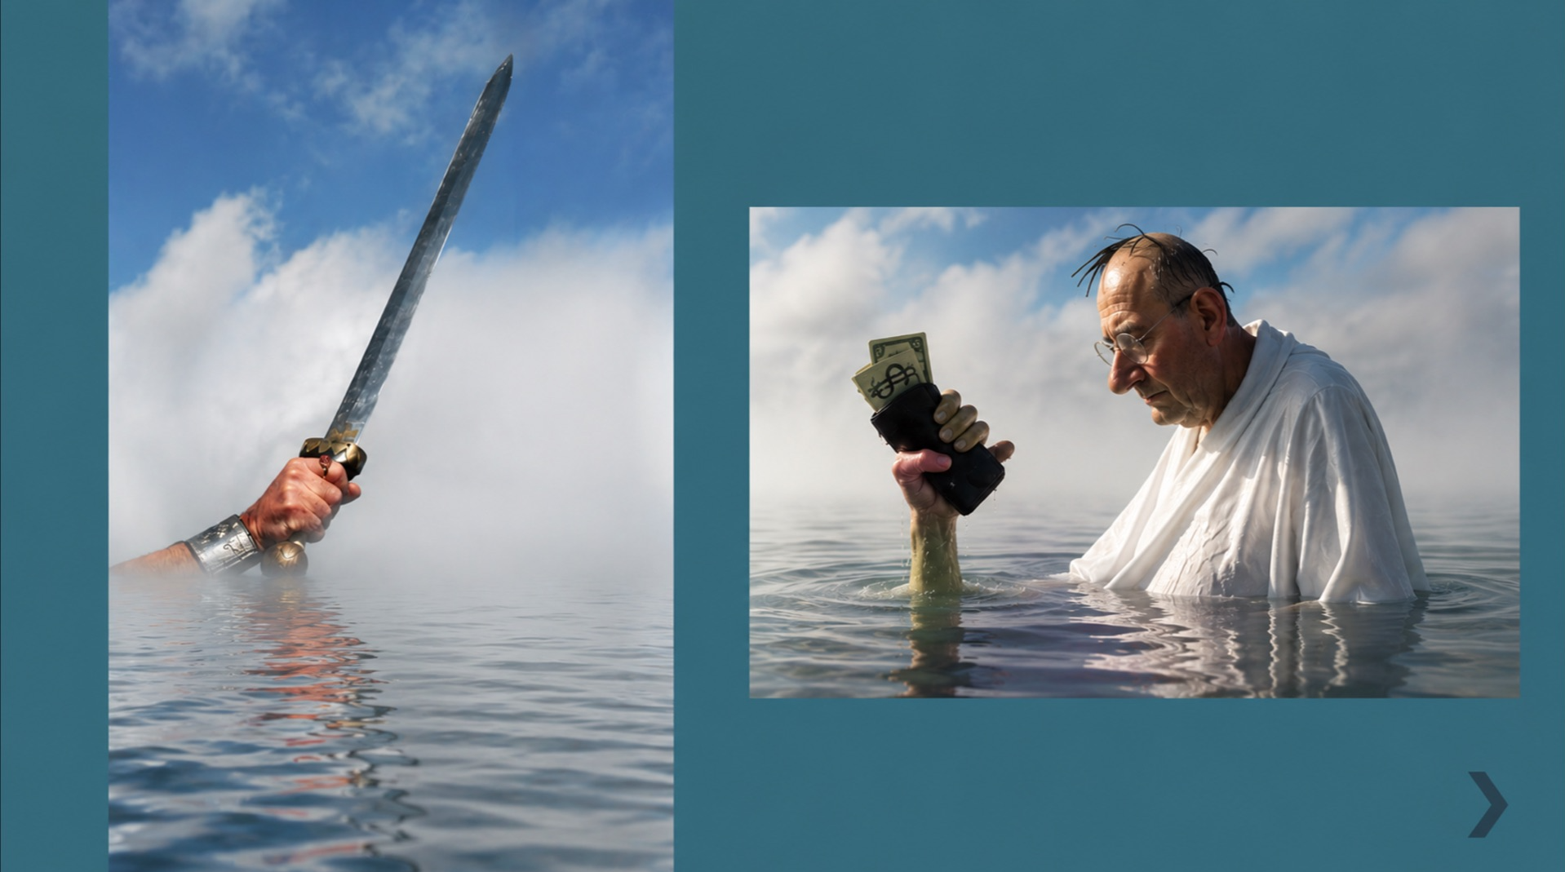
And that’s not us. And so, we’re going to give throw it in our baptismal. All of us gets baptized—the Achilles and his heel go in there.

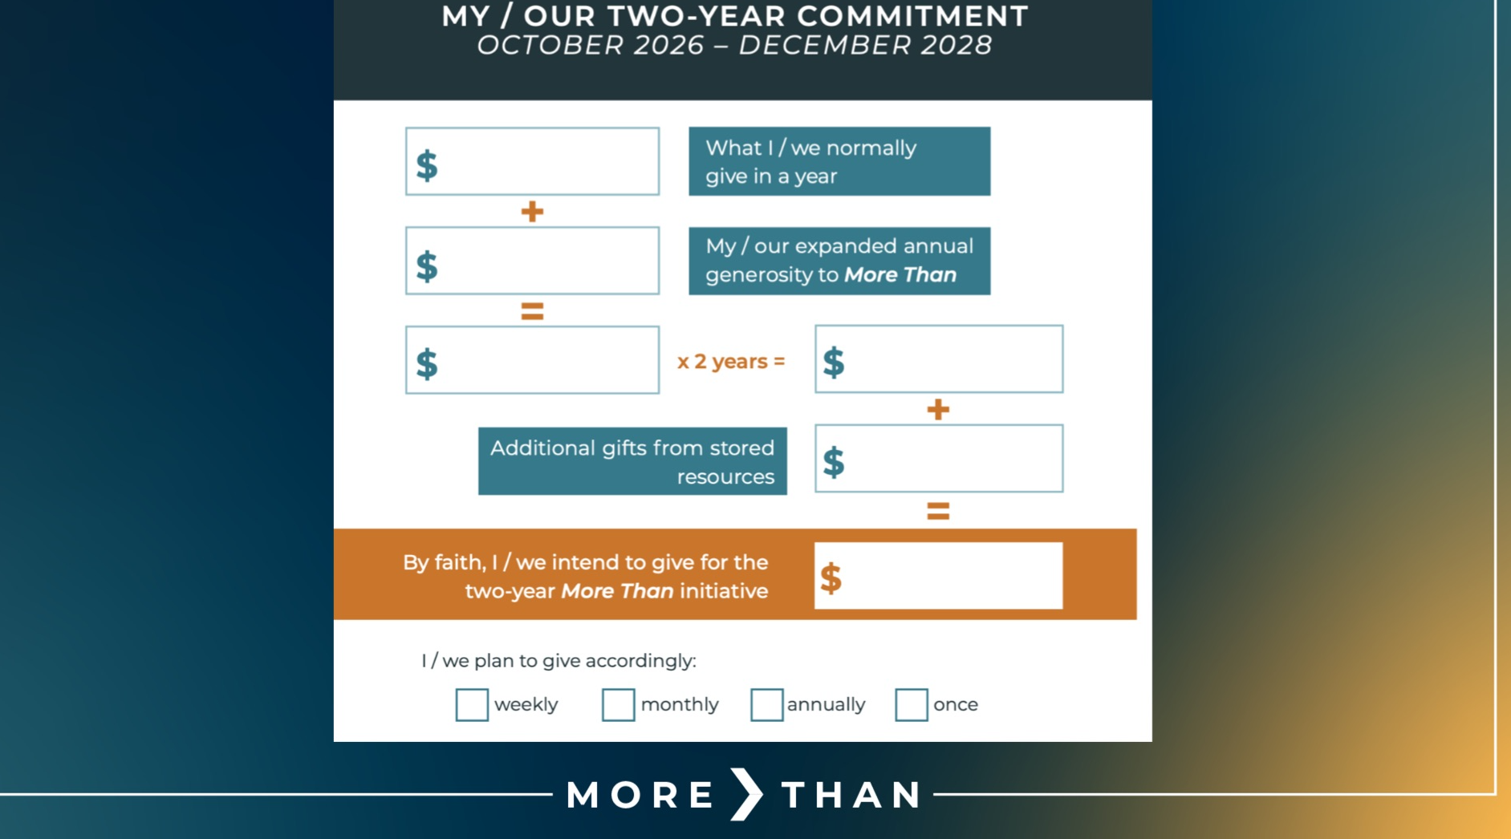

Anyway, let me show you how the card get fills out and what it means. The first blank is for whatever you normally give per year. Some of you, many of you, will be putting a zero in there, because that’s been your pattern. But that’s not your future. This is a card of honesty, so just put that. And then the second blank is for how God is expanding your generosity. What’s the new you look like? How are things going to change now that God is growing you in this way? You’re going to add those two numbers together and then multiply times two, since that will be for the two years of this event that we’re doing. And then “stored resources” is for things that you might have or maybe some savings account or retirement account that you might want to give from. And you’re going to give that, and then total it up right there.
I’m showing you this, and I want to show you how the Cassidys are doing it. And hopefully, it will help you, not just more than by illustrating, but help you understand what we’re asking everyone to do. For our sake, at the Cassidys, we tithe regularly to Grace Covenant Church. And here’s what we did for expanding our giving. Melinda and I were going back and forth. And we had a wedding last year for our daughter, and we’re having a wedding in two weeks for our other daughter. And then we just thought, Wait, the bride of Christ. You know, what if the money that we had set aside for our two girls to get married, what if we had a wedding for the bride of Christ? So, we’re putting that budget amount (at the least, I actually learned last hour)—"At least wedding” [writes on the card]. So, that’s going to be our above and beyond. We’re going to tithe, then the wedding amount, and when you combine that it’s the tithe plus the wedding. And then it’s times two for two years, so it’s tithe plus wedding.
And for additional resources, I want you to see how I’m going to fill this out. I’m going to put “Matt’s estate sale” [writes on the card]---you’ve heard all about it. I don’t know what that number is, so they can’t add it to the total amount. But I’m putting this on the card because anything we sell in the next year or so in my little adventure, I’m putting on there.
And in addition to this I’m going to put “surprise.” [Writes that on the card.] And the reason for that is there might be some money that comes our way, maybe in a bonus or an aunt that we never knew about that passes away and leaves me a fortune. We don’t how much we’re going to give, but we’re going to put it toward this campaign.
And the reason, again, even though the bank and our accounting people don’t know what any of these numbers mean, it’s fine for them. I’m putting this down for me. I’m putting a stake in the ground, saying, “Tithe plus two weddings and a bunch of other stuff.” And then that total is going to go right there. And I want them to know I’m giving monthly for the next two years that way. [Checks the “monthly” box.]
I hope that’s helpful.
So, what we’re going to do now is have a five-minute time of prayer. We’ll have some music playing, and feel free to talk amongst yourselves, to the people in your family, about how best to fill out that card. And in five minutes I’m going to come up here, and I’m going to put our card into the baptismal. And at that point you’re all released to come up and put your cards in. And then we’re going to worship together. We’ll finish by singing “I Surrender All.” It will be the climax of our time together for these last six or seven weeks. We’ll sing “I Surrender All,” and then I’ll come back up, and I’ll close our time. Okay?
Now we’ll have five minutes of reflective prayer. How does God want you to use the resources that He’s lent you to fill heaven and make God famous?

[Benediction]

The earth is the Lord’s, and everything in it, every nation, every throne, every ruler bows beneath His reign. He is the Lord, strong and mighty. He is the King of glory. So go from this place under His rule, not your own. Let Him be King over your work and your rest, King over your fears and your plans, King over all your life. And may the King of glory Himself go with You. Amen.

